Dig. Sig. Proc. Project 99: DAC/ADC/FFT
Email one pdf file (not msword), and turn in 1 hardcopy per group of students, , 1 hardcopy kept by instructor.

Federico Faggin and Nolan Bushnell
Email: name1@uncc.edu and name2@uncc.edu

Abstract—This report summarizes Project xx: DAC/ADC/FFT. In this project, the mbed.org interface was used to compile a project with the FRDM-K64F acting as an Ethernet client that produces a periodic sawtooth on the DAC with sample period T=xx us, uses the ADC to digitize 1024 samples of the sawtooth signal, and finally performs an FFT on the time signal using the CMSIS Library. A NetBeans GUI server running on a laptop was used to fetch the time and frequency domain data, and display the 1024 points for each. Results included are: 1) a software flowchart, 2) time plot of 1024 sample, and 3) FFT plot.. blah blah blah) blah blah blah) blah blah blah) blah blah blah) blah blah blah) blah blah blah) blah blah blah) blah blah blah) blah blah blah) blah blah blah) blah blah blah.

Introduction
Project reports may not exceed two single-sided pages. The FRDM-K64F board includes a 12-bit DAC (digital-to-analog converter), a 16-bit ADC, FFT library, and Ethernet socket/TCP library. In this project, a sawtooth of xx KHz was created using the DAC, the xx KHz 12-bit ADC digitized 1024 points of the sawtooth signal, and a 1024-point FFT is performed. The interface and FRDM-K64F mbed code are based on the ECGR6114 tutorial [1].
In the following section, the theory of the quantization noise of the ADC, theory of FFT, and theoretical spectrum of a sawtooth are first reviewed. The following section outlines a flowchart of the FRDM-K64F mbed code. The final section presents experimental results using the FRDM-K64F, as displayed in the NetBeans interface. The following sections present the theory, software code, and measured data.

Analysis and Theory
The 12-bit DAC quantization noise is considerably greater than the quantization noise of the 12-bit DAC. Assuming the DAQ noise dominates, the system quantization noise and associated noise power specral density and Sq(ω) is:

where q[n] is the quantization noise, Δ is blah blah, is blah blah..
The FFT of a time sequence x[n] is equivalent to a DFT (discrete Fourier transform) [2]:

Freescale, Kinetis are registered trademarks of Freescale Semiconductor, Inc. ARM, Cortex and Keil are registered trademarks of ARM Limited (or its subsidiaries). All other product or service names are the property of their respective owners.
where N is the number of time samples, X[k] is blah blah, is blah blah blah blah blah blah blah blah.
Finally, the DAC generates a 1024-point sawtooth with frequency of xx rad/samples and xx volts peak-peak. The first four spectral components of a theoretical 1024-point DFT of the sawtooth consist of a dc component X[0]=xx, a fundamental frequency component at xx rad/sample, with X[??]=xx, and a second harmonic at X[??]=xx, and a third homonic at X[??]=xx.

FRDM-K64F Software Code Flowchart
For your software, do not include the entirety of your code, rather, include only a flowchart of the overall program. The software to implement the blah, blah, blah, blah Fig. 1 below. The first step in the flowchart of Fig. 1 is blah, blah, blah, blah blah, blah, blah, blah blah, blah, blah, blah blah, blah, blah, blah blah, blah, blah, blah blah, blah, blah, blah blah, blah, blah, blah blah, blah, blah, blah blah, blah, blah, blah blah, blah, blah, blah blah, blah, blah, blah blah, blah, blah, blah blah, blah, blah, blah blah, blah, blah, blah blah, blah, blah, blah blah, blah, blah, blah
Startrt
Initialize Ethernetrt
Start ADC & DAC
1024 points?
FFT
End
yes
no

Fig. 1. Code flowchart.

The last step in the flowchart of Fig. 1 is blah, blah, blah, blah blah, blah, blah, blah blah, blah, blah, blah blah, blah, blah, blah blah, blah, blah, blah blah, blah, blah, blah blah, blah, blah, blah blah, blah, blah, blah blah, blah, blah, blah blah, blah, blah, blah blah, blah, blah, blah blah, blah, blah, blah blah, blah, blah, blah blah, blah, blah, blah blah, blah, blah, blah blah, blah, blah, blah

Measured Data
For your measured data, include only the most important data and oscilloscope plots, and/or any specific items required by the project description. The software was loaded onto the FRDM-K64F board and the green LED lit as the getTime button was presssed in the NetBeans GUI. The time-domain data x[n] for the sawtooth is shownin Fig. 2.
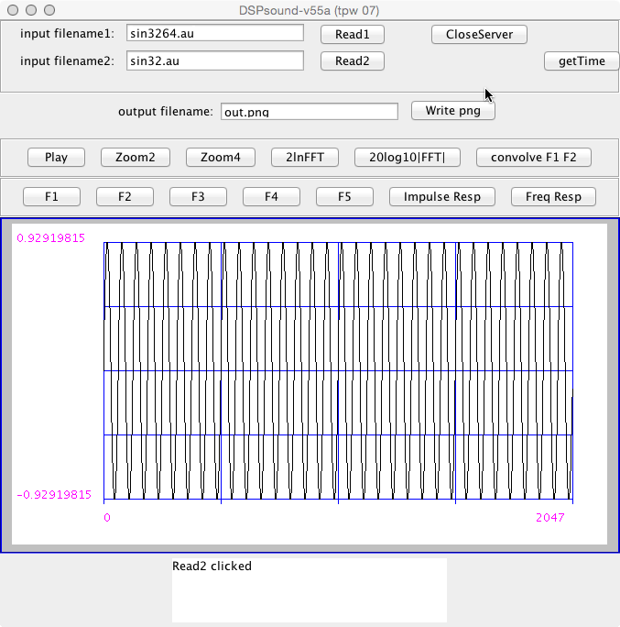
Fig. 2. Measured tim-domain data x[n] for 1024-point sawtooth, with DAC connected to ADC of FRDM-K64F.

Blah b blah blah lah blah blah blah blah blah blah blah blah blah lah blah blah blah blah blah blah blah lah blah lah blah blah blah blah blah blah blah

In addition, the magnitude of the FFT is blah blah lah blah blah blah blah blah blah blah blah ablah blah blah in Fig. 3. blah blah lah blah blah blah blah blah blah blah blah blah lah blah blah blah blah blah blah blah blah blah lah blah blah blah blah blah blah blah blah blah lah blah blah blah blah blah blah blah blah blah lah blah blah blah blah blah blah blah
blah blah lah blah blah blah blah blah blah blah blah blah lah blah blah blah blah blah blah blah blah blah lah blah blah blah blah blah blah blah blah blah lah blah blah blah blah blah blah blah blah blah lah blah blah blah blah blah blah blah blah blah lah blah blah blah blah blah blah blah blah blah lah blah blah blah blah blah blah blah blah blah lah blah blah blah blah blah blah blah blah blah lah blah blah blah blah blah blah blah blah blah lah blah blah blah blah blah blah blah blah blah lah blah blah blah blah blah blah blah
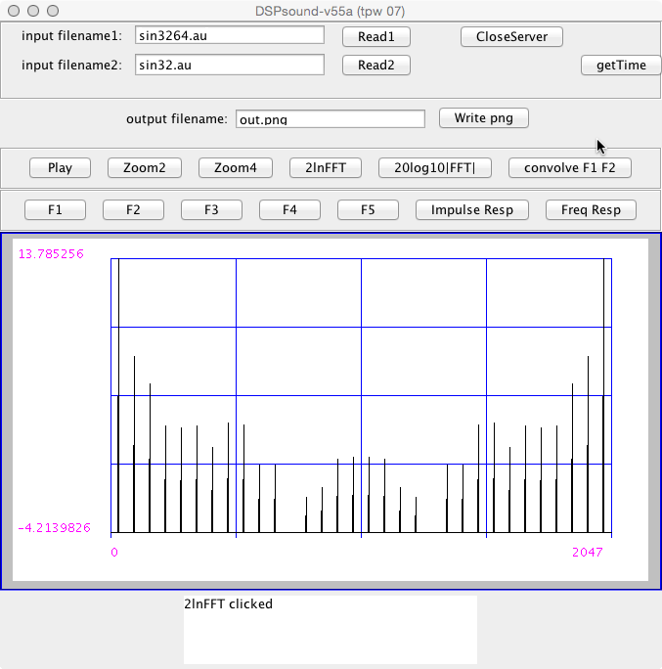Fig. 3. Magnitude of 1024-point FFT showing measured frequency spectrum |X[k]| in dB of data x[n].

As part of the experiment, measured dc ad first 3 harmonics are compared to the previous theoretical values in Table I below. blah blah lah blah blah blah blah blah blah blah blah blah lah blah blah blah blah blah blah blah blah blah lah blah blah blah blah blah blah blah blah blah lah blah blah blah blah blah blah blah blah blah lah blah blah blah blah blah blah blah
- Measured Data Summary
Harmonic | Expected | Measured
Dc, X[0] | 3.3 dB | 4.4 dB
First harmonic, |X[??]| | 11 dB | 12 dB
Second harmonic, |X[??]]| | 13 dB | 14 dB
Third harmonic, |X[??]]| | 15 dB | 16 dB

References (Two references minumum are required)
At least 1 reference must be an IEEE paper
- FRDM-K64F Freedom Module User’s Guide. [Online]. Available: http://cache.freescale.com/files/32bit/doc/user_guide/FRDMK64FUG.pdfh
- Your favorite FFT textbook.
- T.P. Weldon, J.M.C. Covington III, K.L. Smith, and R.S. Adams ``Performance of Digital Discrete-Time Implementations of Non-Foster Circuit Elements,'' 2015 IEEE Int. Sym. onCircuits and Systems, Lisbon, Portugal, May 24-27, 2015.
- T.P. Weldon, J.M.C. Covington III, K.L. Smith, and R.S. Adams, ``Stability Conditions for a Digital Discrete-Time Non-Foster Circuit Element,'' 2015 IEEE Int. Symposium on Antennas and Propagation, Vancouver, BC, Canada, July 19-25, 2015.

