Embedded Sig. Proc. Project 99: DAC/Blinky
Email one pdf file (not msword), and turn in 3 hardcopies per group of 2 students, , 1 hardcopy kept by instructor.

Federico Faggin and Nolan Bushnell
Email: name1@uncc.edu and name2@uncc.edu

Abstract—This report summarizes Project 0: DAC/Blinky. In this project, the mbed.org interface was used to compile a FRDM-K64F project that caused LED_2 (red LED) to flash on and off approximately twice per second, and caused the digital-to-analog converter (DAC) to implement negative capacitance. Results included are: 1) software code, 2) measured clock frequencies and capacitance, and 3) oscilloscope waveforms.

Introduction
Project reports may not exceed one page. The FRDM-K64F board includes a 10-bit digital-to-analog converter (DAC) and a red light-emitting diode [1]. The board is to be programmed to 1) blink the red LED on and off approximately at a rate of 2.5 Hz, 2) set the system core clock to 120 MHz, 3) set the bus clock to 60 MHz, and 4) implement a capacitance of 10 nF at the DAC output. The following sections present the theory, software code, and measured data.

Theory
The negative capacitance is based on the theory provided in [2] and [3], where the DAC current i(t) is

where v[n] is the analog-to-digital converter ADC sampled voltage, C is the capacitance, and T is the ADC and DAC sampling period.

Software Code
For your software, do not include the entirety of your code, rather, include only the most important lines of code for a task. The software to implement the blinking LED is provided in the software code excerptof Fig. 1 below.
DigitalOut led_green(LED_GREEN);
…
led_green = 0;
wait(0.5f);
led_green = 1;

Fig. 1. Code excerpt to implement flashing LED.

The software to implement the negative capacitance of (1) is implemented in the software excerpt of Fig. 2 below:
Freescale, Kinetis are registered trademarks of Freescale Semiconductor, Inc. ARM, Cortex and Keil are registered trademarks of ARM Limited (or its subsidiaries). All other product or service names are the property of their respective owners.
int cap= 10, period=0.001,current=0;
…
current = (uint32_t) (cap/period)*(vin – vin_old);

Fig. 2. Code excerpt to implement current i(t).

Measured Data
For your measured data, include only the most important data and oscilloscope plots, and/or any specific items required by the project description. The software was loaded onto the FRDM-K64F board and the red LED bliked at 2.5 Hz, as expected. As part of the experiment, K64F clock frequencies and capacitance were also measured and are given in Table I below.
- Measured Data Summary
Parameter | Expected | Measured
System Core Clock | 120 MHz | 100 MHz
Bus clock | 60 MHz | 25 MHz
Measured Capacitance | -10 nF | -8.8 nF

In addition, the waveforms at the DAC were measured using a Tek2001a oscilloscope, using a 200 MHz triangle wave, and shown in Fig. 3 below. The -8.8 nF measured capacitance in Table I is based on i=Cdv/dt for the voltage waveform and current waveform in Fig. 3.
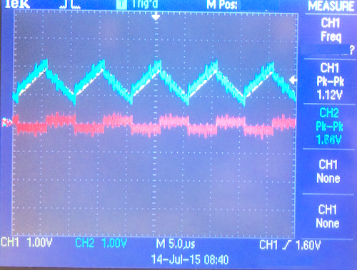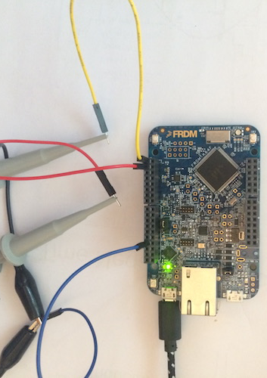
(a) (b)
Fig. 3. (a) Measured data for negative capacitor. Top blue trace is voltage, bottom red trace is current. (b) FRDM-K64F prototype with test probes.

References (Two references minumum are required)
At least 1 reference must be an IEEE paper
- FRDM-K64F Freedom Module User’s Guide. [Online]. Available: http://cache.freescale.com/files/32bit/doc/user_guide/FRDMK64FUG.pdfh
- T.P. Weldon, J.M.C. Covington III, K.L. Smith, and R.S. Adams ``Performance of Digital Discrete-Time Implementations of Non-Foster Circuit Elements,'' 2015 IEEE Int. Sym. on Circuits and Systems, Lisbon, Portugal, May 24-27, 2015.
- T.P. Weldon, J.M.C. Covington III, K.L. Smith, and R.S. Adams, ``Stability Conditions for a Digital Discrete-Time Non-Foster Circuit Element,'' 2015 IEEE Int. Symposium on Antennas and Propagation, Vancouver, BC, Canada, July 19-25, 2015.

